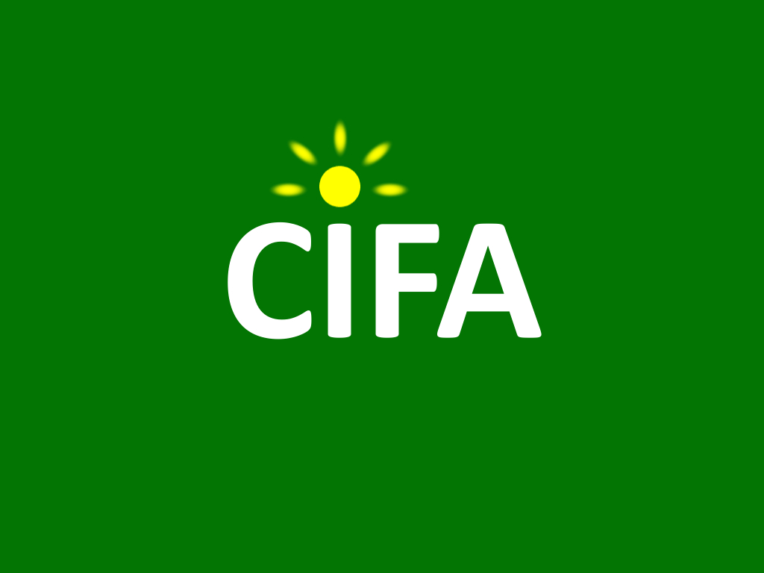The CIFA Trust

Safeguarding Policy

February 2019

Purpose
The purpose of this policy is to protect people, particularly children, at risk adults and beneficiaries of assistance, from any harm that may be caused due to their coming into contact with The CIFA Trust. This includes harm arising from:

- The conduct of CIFA personnel including trustees, volunteers, interns, or contracted staff
- The conduct of any other personnel associated with CIFA, notably those working with our partner organisations in Malawi, Ethiopia and Kenya
- The design and implementation of CIFA’s overseas programmes and other activities

The policy replaces CIFA’s 2006 Child Protection Policy, following a review by the trustees in early 2019, and is based on guidance provided by BOND and OSCR.

The policy lays out the commitments made by CIFA, and informs CIFA’s personnel and associated personnel of their responsibilities in relation to safeguarding.

What is safeguarding?
Safeguarding means protecting peoples' health, wellbeing and human rights, and enabling them to live free from harm, abuse and neglect. Specifically, it means protecting people, including children and at risk adults, from harm that arises from coming into contact with our personnel or programmes.

Policy Statement
The CIFA Trust believes that everyone we come into contact with, regardless of age, gender identity, disability, sexual orientation or ethnic origin has the right to be protected from all forms of harm, abuse, neglect and exploitation. CIFA will not tolerate abuse and exploitation by its personnel or associated personnel.

This policy will address child safeguarding, adult safeguarding, and protection from sexual exploitation and abuse.

CIFA commits to addressing safeguarding throughout its work, through the three pillars of prevention, reporting and response.

Prevention

CIFA responsibilities
CIFA will:
- Ensure all personnel and associated personnel have access to, are familiar with, and know their responsibilities within this policy. CIFA and its trustees will also refer to OSCR’s safeguarding guidance on the OSCR website, and relevant publications such as “Guidance and Good Practice for Charity Trustees”.
- Design and undertake all its programmes and activities in a way that protects people from any risk of harm that may arise from their coming into contact with CIFA. This includes the way in which information about individuals in our programmes is gathered and communicated.
- Consider safeguarding when appointing trustees, and ensure that prospective and existing trustees are fully aware of their responsibilities as detailed in this policy document and include this policy in the Code of Conduct signed by all new trustees.
- Ensure that associated personnel such as interns and consultants are also fully aware of their safeguarding responsibilities.
- Take safeguarding into account when drawing up MOUs, contracts and any other official documents.
- Follow up on reports of safeguarding concerns promptly and according to due process

Personnel responsibilities
Child safeguarding
CIFA personnel and associated personnel must not:
- Engage in sexual activity with anyone under the age of 18
- Sexually abuse or exploit children
- Subject a child to physical, emotional or psychological abuse, or neglect
- Engage in any commercially exploitative activities with children including child labour or trafficking

Adult safeguarding
CIFA personnel and associated personnel must not:
- Sexually abuse or exploit at risk adults
- Subject an at risk adult to physical, emotional or psychological abuse, or neglect

Protection from sexual exploitation and abuse
CIFA personnel and associated personnel must not:
- Exchange money, employment, goods or services for sexual activity. This includes any exchange of assistance that is due to beneficiaries of assistance
- Engage in any sexual relationships with beneficiaries of assistance, since they are based on inherently unequal power dynamics

Additionally, CIFA personnel and associated personnel are obliged to:
- Contribute to creating and maintaining an environment that prevents safeguarding violations and promotes the implementation of the Safeguarding Policy
- Report any concerns or suspicions regarding safeguarding violations by CIFA personnel or associated personnel to the CIFA Chairman

Enabling reports
CIFA will ensure that safe, appropriate, accessible means of reporting safeguarding concerns are made available to anybody, including members of the public, partners and official bodies.

How to report a safeguarding concern
Personnel or associated personnel who have a complaint or concern relating to safeguarding should report it immediately to the CIFA Chairman via the CIFA website. If they do not feel comfortable reporting to the CIFA Chairman (for example if they feel that the report will not be taken seriously, or if that person is implicated in the concern) they may report to the CIFA Secretary via the CIFA website.

Response
CIFA will follow up safeguarding reports and concerns at board level, and in accordance with its legal and statutory obligations.

Confidentiality
It is essential that confidentiality in maintained at all stages of the process when dealing with safeguarding concerns. Information relating to the concern and subsequent case management should be shared on a need to know basis only, and should be kept secure at all times.

Associated policies
Code of Conduct
Equal Opportunities Policy

Glossary of Terms
Beneficiary of Assistance
Someone who directly receives support from CIFA’s programmes. Note that misuse of power can also apply to the wider community that the CIFA serves, and also can include exploitation by giving the perception of being in a position of power.

Child
A person below the age of 18

Harm
Psychological, physical and any other infringement of an individual’s rights

Psychological harm
Emotional or psychological abuse, including (but not limited to) humiliating and degrading treatment such as bad name calling, constant criticism, belittling, persistent shaming, solitary confinement and isolation

Protection from Sexual Exploitation and Abuse (PSEA)
The term used by the humanitarian and development community to refer to the prevention of sexual exploitation and abuse of affected populations by personnel or associated personnel. The term derives from the United Nations Secretary General’s Bulletin on Special Measures for Protection from Sexual Exploitation and Abuse (ST/SGB/2003/13)

Safeguarding
In the UK, safeguarding means protecting peoples' health, wellbeing and human rights, and enabling them to live free from harm, abuse and neglect

In our sector, we understand it to mean protecting people, including children and at risk adults, from harm that arises from coming into contact with our personnel or programmes.

One donor definition is as follows:
Safeguarding means taking all reasonable steps to prevent harm, particularly sexual exploitation, abuse and harassment from occurring; to protect people, especially vulnerable adults and children, from that harm; and to respond appropriately when harm does occur.
This definition draws from our values and principles and shapes our culture. It pays specific attention to preventing and responding to harm from any potential, actual or attempted abuse of power, trust, or vulnerability, especially for sexual purposes.

Safeguarding applies consistently and without exception across our programmes, partners and personnel. It requires proactively identifying, preventing and guarding against all risks of harm, exploitation and abuse and having mature, accountable and transparent systems for response, reporting and learning when risks materialise. Those systems must be survivor-centred and also protect those accused until proven guilty.
Safeguarding puts beneficiaries and affected persons at the centre of all we do.

Sexual abuse
The term ‘sexual abuse’ means the actual or threatened physical intrusion of a sexual nature, whether by force or under unequal or coercive conditions.

Sexual exploitation
The term ‘sexual exploitation’ means any actual or attempted abuse of a position of vulnerability, differential power, or trust, for sexual purposes, including, but not limited to, profiting monetarily, socially or politically from the sexual exploitation of another. This definition incudes human trafficking and modern slavery.

Survivor
The person who has been abused or exploited. The term ‘survivor’ is often used in preference to ‘victim’ as it implies strength, resilience and the capacity to survive, however it is the individual’s choice how they wish to identify themselves.

At risk adult
Sometimes also referred to as vulnerable adult. A person who is or may be in need of care by reason of mental or other disability, age or illness; and who is or may be unable to take care of him or herself, or unable to protect him or herself against significant harm or exploitation.

